Smart Fleet Management Website of ABC-Trans Company Guidelines (Implementation, Coding Milestones, and Milstones)

- Rules for Coding Website:
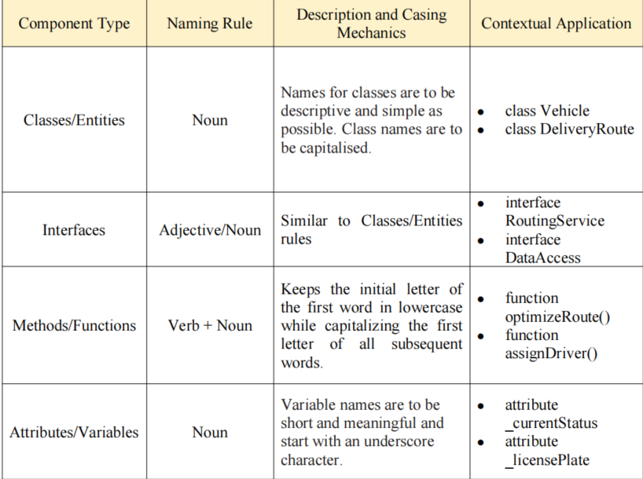
B. Database for the System

